Martin Frederick Adam Jr.
September 12, 1949 – October 1, 2020

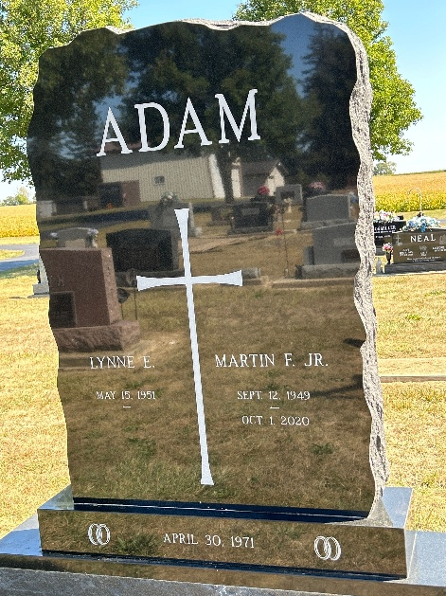
Photo by Barbara Baker Anderson

Martin Frederick “Marty” Adam, Jr., 71, of Ossian, Indiana passed away on Thursday, October 1, 2020 in his home surrounded by family after his battle with cancer. Born September 12, 1949 in Fort Wayne, he was the son of the late Martin F. Adam, Sr. and Helen (Scheumann) Adam.
He was baptized and confirmed at Bethlehem Lutheran Church, Ossian. He graduated from Ossian High School in 1967. He married Lynne Smith on April 30, 1971.
He spent his career in tool and die and retired from Roembke Manufacturing & Design after 33 years. In his free time, he enjoyed watching his grandchildren in their sporting events, spending time with family, pheasant hunting, fishing, farming, and traveling.
Surviving family include his wife, Lynne of 49 years; daughters, Amanda Branstrator and Katrina (Mike) McWilliams; son, Jacob (Danielle) Adam; grandchildren, Justin (fiancé Cassandra), Kyle, Katlynn, Josh, and Grant; sisters, Donna Myers and Arlene (Jake) Bruick; and several nieces and nephews.
Besides his parents, he was also preceded in passing by his sisters, Carol Kukelhan and Geraldine Smith.
Funeral service will be held at 10:00 a.m. on Monday, October 5, 2020 at Faith Lutheran Church, 3416 East 900 North, Roanoke with visitation one hour prior. Visitation will also be from 2:00 p.m. to 5:00 p.m. on Sunday, October 4, 2020 at Elzey-Patterson-Rodak Funeral Home, 120 West Mill St, Ossian. Burial will be in Oak Lawn Cemetery, Ossian. In lieu of flowers, memorials may be made in Marty’s name to Faith Lutheran Church, Roanoke.

Elzey-Patterson-Rodak Funeral Home, Wells County, Indiana

