Martin F. Adam
December 31, 1910 – September 21, 1984

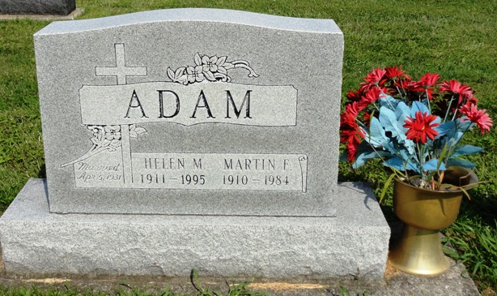
Photo by HoosierGirl88

Martin F. Adam
in the Indiana, U.S., Death Certificates, 1899-2017

Name Martin F. Adam
Gender Male
Race White
Marital Status Married
Age 73
Birth Date 31 Dec 1910
Birth Place Indiana
Death Date 21 Sep 1984
Death Place Ossian, Wells, Indiana, USA
Death Registration Date 1984
Father Jacob Adam
Mother Mary Bearman
Spouse Helen Scheumann
Informant Helen Adam; wife; Ossian, Indiana
Burial September 24, 1984; Oak Lawn Cemetery; Ossian, Indiana

