Helen M. (Scheumann) Adam
November 21, 1911 – November 13, 1995

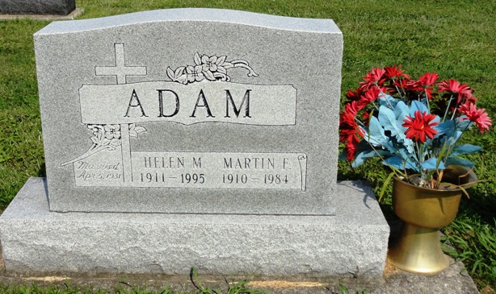
Photo by HoosierGirl88

HELEN M. ADAM, 83, of rural Ossian died Monday in Golden Years Homestead, Fort Wayne. The Adams County native was the widow of Martin F. Sr., who died in 1984.
Surviving are daughters, Donna Myers and Gerry Smith, both of Ossian, and Arlene Bradtmueller of Fort Wayne; son, Martin F. Jr. of Ossian; sisters, Leona Werling of Ossian and Eldora Weldon of Grahm, Mo.; brothers, Rudy Scheumann of Colon, Mich., and Melvin Scheumann of Ossian; 23 grandchildren; and 30 great-grandchildren.
Services are 1 p.m. Friday in New Hope Lutheran Church, Ossian, with burial in Oak Lawn Cemetery. Calling is 2 to 9 p.m. tomorrow in Elzey & Haggard Ossian Chapel and noon to 1 p.m. Friday in the church. Preferred memorials are gifts to the church or "The Lutheran Hour" radio program.

News-Sentinel, The (Allen County, Indiana)
November 15, 1995

