Vincent Abrams
July 6, 1896 – July 15, 1961

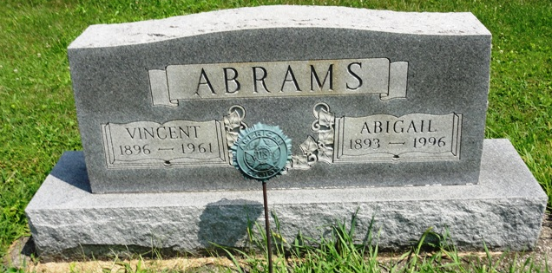
Photo by HoosierGirl88

Vincent Abrams
in the Indiana, U.S., Death Certificates, 1899-2017

Name Vincent Abrams
Gender Male
Race White
Age 68
Marital Status Married
Birth Date 6 Jul 1896
Birth Place Indiana
Death Date 15 Jul 1961
Death Place North Webster, Kosciusko, Indiana, USA
Death Registration Date 1961
Father: Not named
Mother: Jessie Burns
Spouse: Anna Abigail Bigham
Informant: Anna Abigail Abrams
Burial: July 18, 1961; Oak Lawn Cemetery; Ossian, Indiana

**
Indiana, U.S., Marriages, 1810-2001

Name Vincent Abrams
Gender Male
Race White
Age 23
Event Type Marriage Registration (Marriage)
Birth Date 6 Jul 1896
Birth Place Wells, Indiana
Marriage Date 27 Sep 1919
Marriage Place Indiana, United States
Residence Place Fort Wayne, Indiana
Father: John Anderson Abrams
Mother: Jessie Burns
Spouse: Abbie Bigham
Page 574

