John Abrams
November 11, 1869 – October 11, 1921

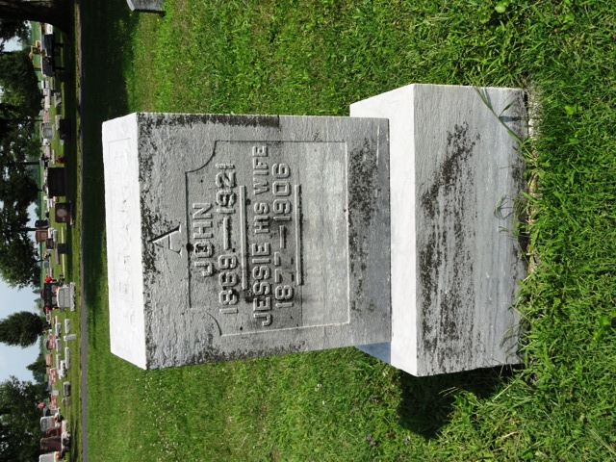
Photo by HoosierGirl88

John Abrams
in the Indiana, Death Certificates, 1899-2011
Name: John Abrams
Gender: Male
Race: White
Age: 51
Marital status: Married
Birth Date: 11 Nov 1869
Birth Place: Wells Co., Ind.
Death Date: 11 Oct 1921
Death Place: Kingsland, Wells, Indiana, USA
Father: James A. Abrams
Mother: Mahaania Redding
Spouse: Fanny Wilson
Informant: Mrs. John Abrams; Kingsland, Indiana
Burial: October 14, 1921; Ossian, Indiana
Mother Gladys Landay
Burial Oak Lawn Cemetery 7/23/1970

