Anna Abigail (Bigham) Abrams
July 2, 1893 – June 22, 1996

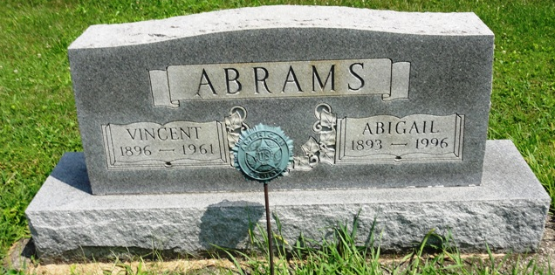
Photo by HoosierGirl88

Anna Abigail Piper
in the Indiana, U.S., Death Certificates, 1899-2017

Name Anna Abigail Piper
[Anna Abigail Bigham]
Gender Female
Race White
Age 102
Marital Status Widowed
Birth Date 2 Jul 1893
Birth Place Paulding County, Ohio
Death Date 22 Jun 1996
Death Place Warsaw, Kosciusko, Indiana, USA
Death Registration Date 1996
Father: William Oliver Bigham
Mother: Ida Lodell Stiverson
Informant: Joyce Ann Phaneuf; daughter; North Webster, Indiana
Burial: June 26, 1996; Oak Lawn Cemetery; Ossian, Indiana

