Marsha Nan (Johnson) Abbett
October 19, 1947 – October 26, 2024

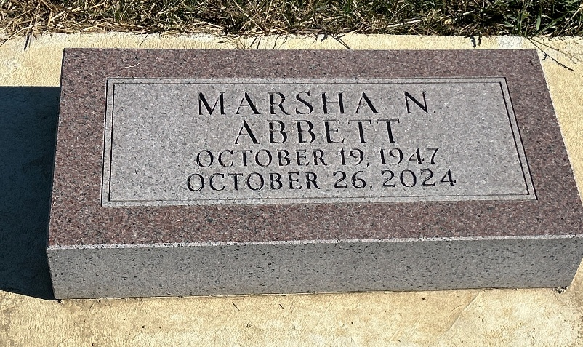
Photo by Barbara Baker Anderson

Marsha Nan (Johnson) Abbett, 77, of Fort Wayne, passed away on
Saturday, October 26, 2024 at Coventry Meadows. Marsha was born
October 19, 1947 in Bluffton, Indiana, daughter of the late Eugene and
Charlotte (Reber) Johnson.
She worked as a photo processor and retired from Howard's Photo
Lab in Fort Wayne.
Surviving is her niece, Michelle Hughes; great nephew, Jordan
Hughes; and several cousins. In addition to her parents, she was
preceded in death by her brother, Bruce Johnson; two-year-old son,
Todd Harris; and infant son, Michael Archbold.
Visitation for Marsha will be held Friday, November 1, 2024 from
11:00 AM to 1:00 PM at Elzey-Patterson-Rodak Home for Funerals,
6810 Old Trail Road, Fort Wayne, Indiana 46809, with funeral services
beginning at 1:00 PM. Burial will be at Oak Lawn Cemetery, Ossian,
IN.
Contributions in Marsha's memory may be made to Heartland
Hospice.

Dignity Memorial, Wells County, Indiana
October 27, 2024

