Merett D. Ruby
March 6, 1895 – December 9, 1895

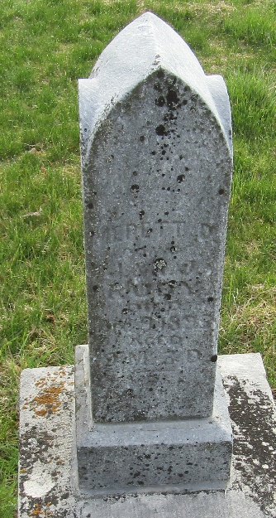

No further information found at this time

