Sarah (Gordon) Rose
February 3, 1824 – August 22, 1898

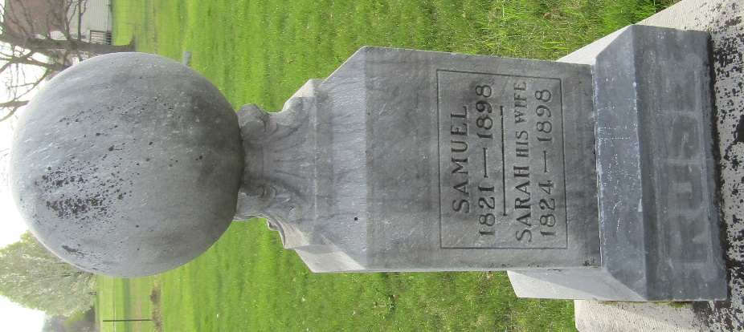

Sarah Rose
Indiana, U.S., WPA Death Index, 1882-1920

Name Sarah Rose
Date Aug 22, 1898
Location Wells County
Age 74 Yr
Gender Female
Race White
Source location County Health Office, Bluffton
Source notes The source of this record is the book H-14 on page 192 within the series produced by the Indiana Works Progress Administration.

