Samuel Rose
1821 – May 9, 1898

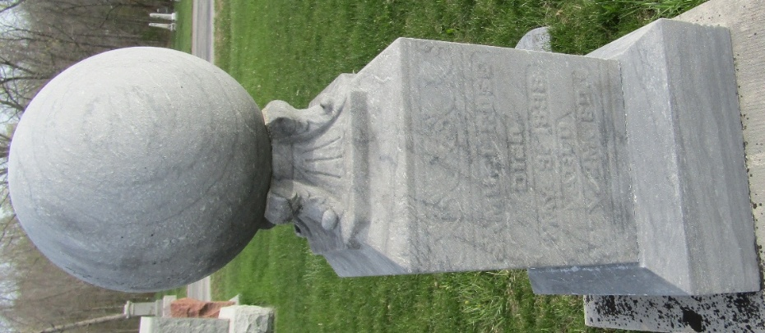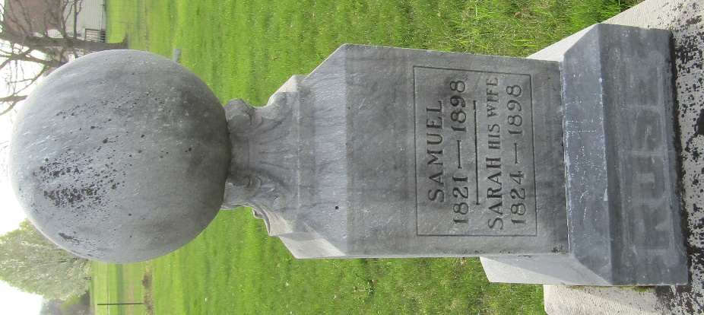

Samuel Rose Dead

Samuel Rose died at his home near Murray last night at eight o'clock. Mr. Rose has been sick for the past eight weeks with the dropsy and this, with his advanced age, caused his death. He was 77 years of age. He has been a resident of this county for ten years, previous to that time having lived in Pennsylvania and Virginia.
Mr. Rose leaves behind him a wife and eight children. Three daughters, Mrs. Lydia Rhodes, Mrs. Rebecca Dougherty and Mrs. Mary Painter live in Harrisburg, Pa., and another daughter, Mrs. Lizzie Saddler, lives in Petersburg, Pa. One son, John, lives in Lowell, Nebraska, and Jacob, in Huntington. Two sons, Joe and Samuel, live in this city. There are also a large number of grandchildren and five great-grandchildren living.
Mr. Rose was an active member of the Christian Church at Murray.
The funeral services will be held at the church in Murray at 10 o'clock tomorrow. Interment at the same place. One daughter, Mrs. Dougherty, has been here since last Friday at the bedside of her father, but the remainder of the children living at a distance will not come to attend the funeral.

Evening News, Wells County, Indiana
Tuesday, May 10, 1898

