Mary P. (Allen) Rockwell
December 26, 1830 – January 3, 1914

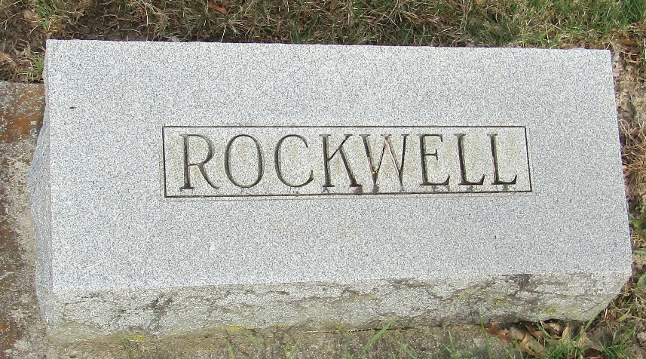

Mary P. Rockwell
Indiana, U.S., Death Certificates, 1899-2017

Name Mary P. Rockwell
Gender Female
Race White
Marital Status Widow
Age 83
Birth Date 26 Dec 1830
Birth Place Wayne Co O,
Death Date 3 Jan 1914
Death Place Harrison, Wells, Indiana, USA
Death Registration Date 1910-1919j
Parents Unknown
Spouse James Rockwell
Informant Mrs. Aaron Wisner; Bluffton, Indiana
Burial January 5, 1914; Murray Cemetery

