Mary (Coons) Rockwell
April 27, 1843 – August 24, 1919

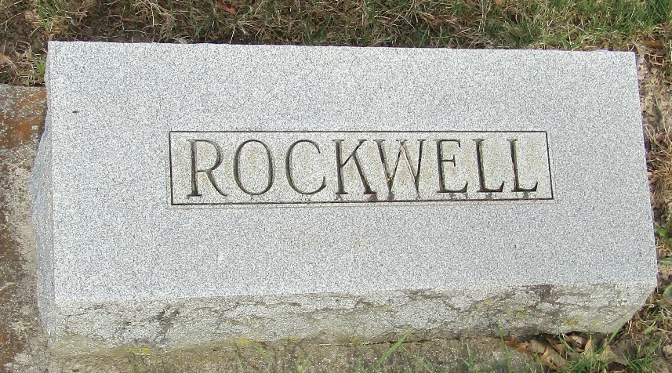

Rockwell

Bluffton, Ind., Aug 24 – Mrs. Mary Rockwell, aged 76, died this morning at the County Infirmary, where she had been an inmate for several years.

Journal Gazette, Allen County, Indiana
August 25, 1919

**
Indiana, U.S., Death Certificates, 1899-2017

Name Mrs. Mary Rockwell
[Mrs. Mary Coons]
Gender Female
Race White
Marital Status Widowed
Age 76
Birth Date 27 Apr 1843
Birth Place Pennsylvania
Death Date 24 Aug 1919
Death Place Maryland, Wells, Indiana, USA
Death Registration Date 1919
Father Coons
Mother Unknown
Spouse Samuel Rockwell
Informant Family; Bluffton, Indiana
Burial August 26, 1919; Murray Cemetery

