Sarah Jane Robison
1849 – December 26, 1869

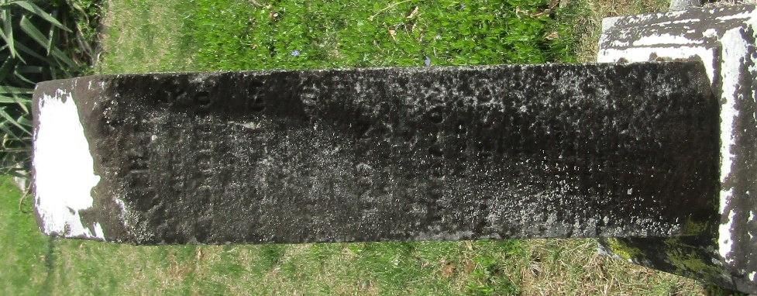

No further information found at this time

