Marion Lafayette Robison
June 14, 1844 – December 31, 1921

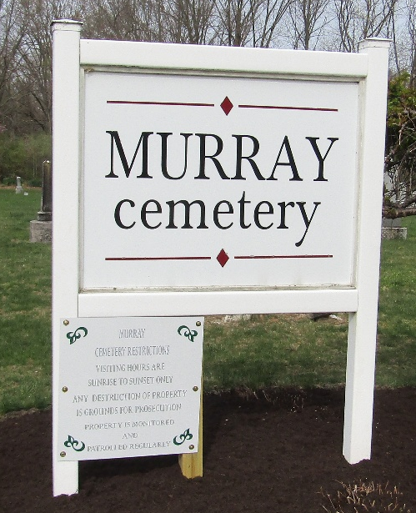

MARION L. ROBISON DIED THIS MORNING
AGED MAN DIED AT 9 O’CLOCK AT HOME OF DAUGHTER, MRS. JOHN FOUTS

Marion L. Robison, age 77, died of paralysis at 9 o’clock this morning at the home of his daughter, Mrs. John Fouts, 309 South Scott Street. He suffered his first stroke three years ago, following which he was able to be around considerably. The second and fatal stroke occurred early Friday morning.
Born on the old Indian Reserve at Fort Wayne, June 14, 1844, Mr. Robison was the son of John and Maria Robison, and at the time of death had attained the age of 77 years, 6 months and 17 days.
His marriage to Emma Brown took place in 1867, his wife dying in 1874. To this union two children were born, Mrs. Fouts of Bluffton, and Fred Robison of Fort Wayne. In 1880, he was married to Elizabeth Guinter, who died in 1913. Children born to this union were Lewellyn Robison and Olive Robison, both of Lima. The daughter is married.
For the last ten years he had been making his home alternately with Mrs. Fouts of Bluffton and Fred Robison of Fort Wayne.
Funeral services will be held at 1:30 o’clock Tuesday afternoon at the Fouts home, with burial at Murray. Rev. Spear will be in charge.

**
Indiana, U.S., Death Certificates, 1899-2017

Name Marion Lafayette Robison
Gender Male
Race White
Marital Status Widowed
Age 77
Birth Date 14 Jun 1844
Birth Place Indianaiana Resene Fox Wayne Indiana
Death Date 31 Dec 1921
Death Place Bluffton, Wells, Indiana, USA
Death Registration Date 1921
Father John Robison
Mother Maria
Informant Mrs. John Fouts; Bluffton, Indiana
Burial January 3, 1922; Murray Cemetery

