James B. Robison
1849 – April 7, 1864

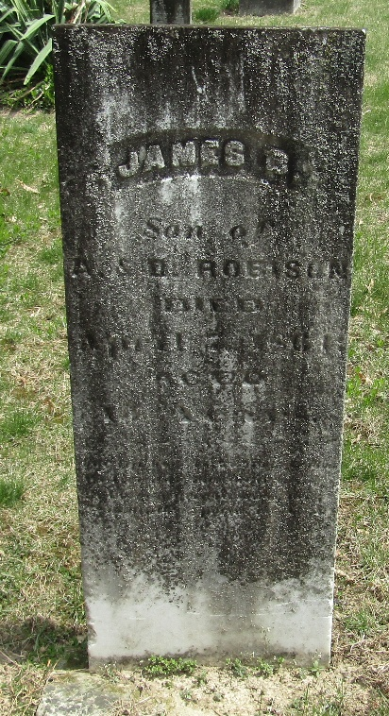

No further information found at this time

