Infant Robison
December 26, 1869 – December 26, 1869

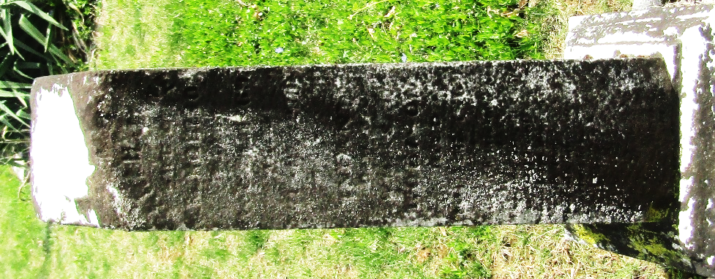

No further information found at this time

