Deborah (McGrew) Robison-Stobie
December 9, 1817 – January 4, 1895

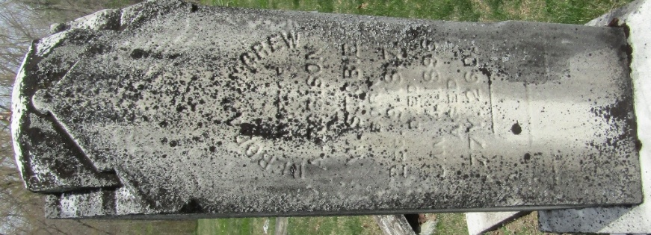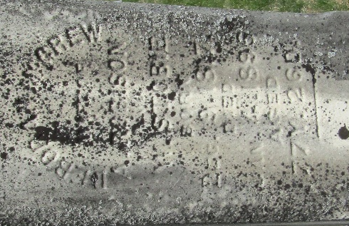

Deborah R McGrew from tree Knutrud

Birth 9 Dec 1817 Sewickley, Westmoreland, Pennsylvania, USA
Marriage 1865
Residence 1880 Wells, Indiana, USA
Death 4 Jan 1895 Indiana, USA
Father James Blackburn McGrew (1781-1836)
Mother Isabella McRae Clark (1782-1866)
Spouse Alexander Robison (1812-1855)
Spouse William Henry Stobie (1808-1885)

