Alexander Robison
1812 – May 8, 1855

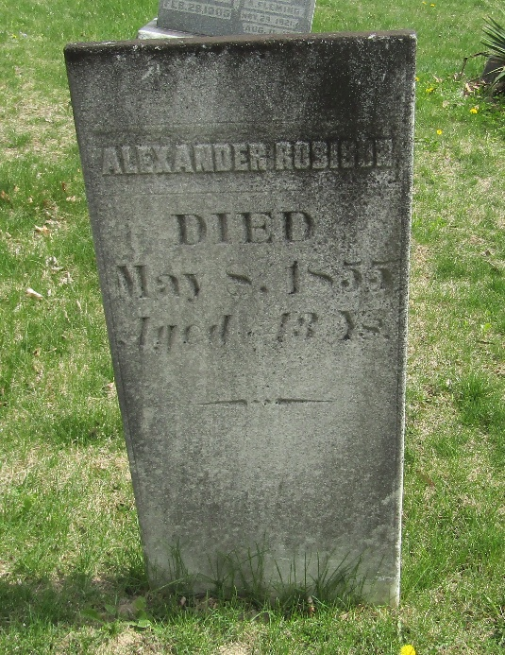

No further information found at this time

