Nora (Johnson) Robart
July 9, 1865 – March 19, 1935

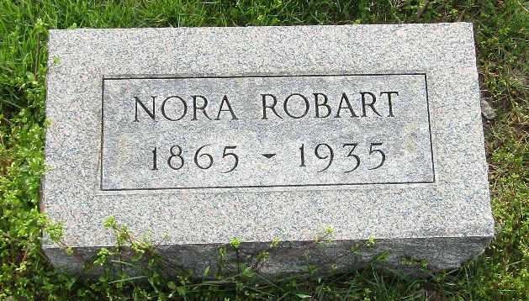

Mrs Nora J Robart
Indiana, U.S., Death Certificates, 1899-2017

Name Mrs Nora J Robart
[Mrs Nora J Johnson]
Gender Female
Race White
Marital Status Married
Age 69
Birth Date 9 Jul 1865
Birth Place Ohio
Death Date 19 Mar 1935
Death Place Fort Wayne, Allen, Indiana, USA
Death Registration Date 1935
Father John Johnson
Mother Phoebe Ponds
Spouse John E Robart
Informant Mrs. Walter Falk; Bluffton, Indiana
Burial March 22, 1935; Murray Cemetery; Wells County, Indiana

