John Emmett Robart
June 30, 1856 – February 18, 1944

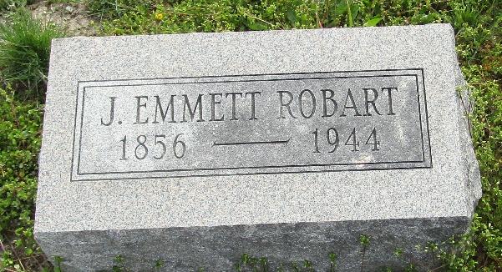

John E Robart
Indiana, U.S., Death Certificates, 1899-2017

Name John E Robart
Gender Male
Race White
Marital Status Widowed
Age 87
Birth Date 30 Jun 1856
Birth Place Dover, Ohio
Death Date 18 Feb 1944
Death Place Bluffton, Wells, Indiana, USA
Death Registration Date 1944
Father Jacob Robart
Mother Pheobe Sink
Spouse Nora Johnson
Informant Mrs. Raymond Gibbons?; Bluffton, Indiana
Burial February 20, 1944; Murray Cemetery

