Massella B. (Kleinknight) Ritchey
1839 - 1892

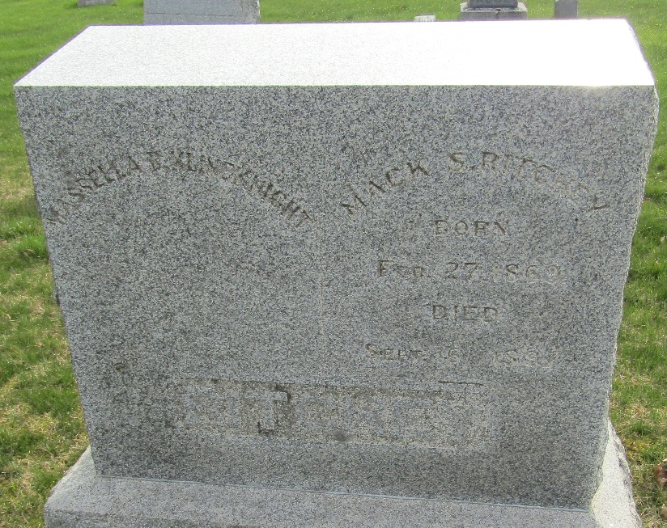

No further information found at this time

