Mack S. Ritchey
February 27, 1869 – September 16, 1897

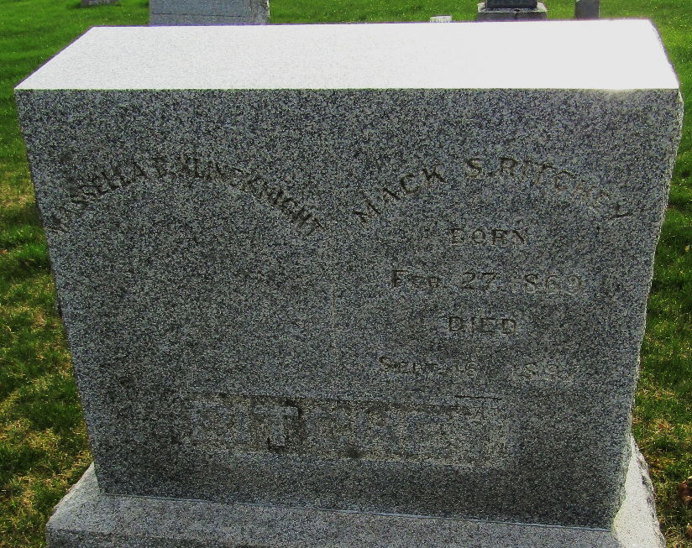

No further information found at this time

