Infant Ritchey

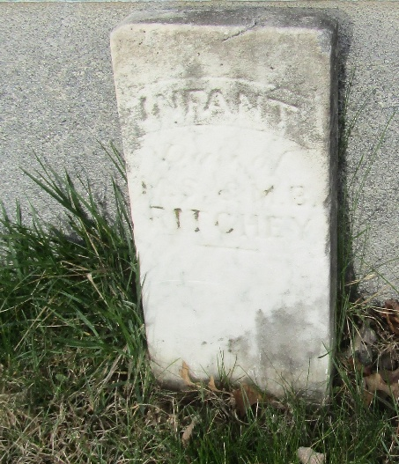

No further information found at this time

