William S. Richey
1816 - May 27, 1875

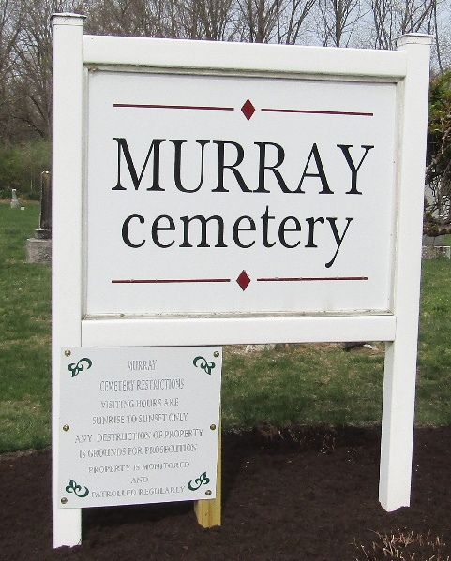

William Richey

Mr. William Richey, an old and highly respected citizen, living in the northeastern part of this township, died last Friday evening and was buried with Granger honors, at Murray, on Sabbath.
He was one of the early settlers of this township. His loss will be deeply felt in his neighborhood.

Bluffton Banner, Wells County, Indiana
Friday, June 4, 1875

