Miranda E. Richey
1842 – August 4, 1848

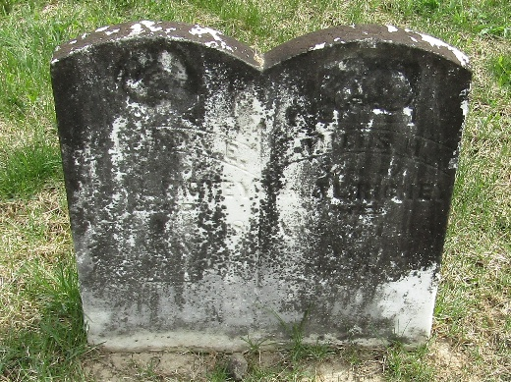

No further information found at this time

