Miles H. Richey
October 15, 1843 – August 15, 1848

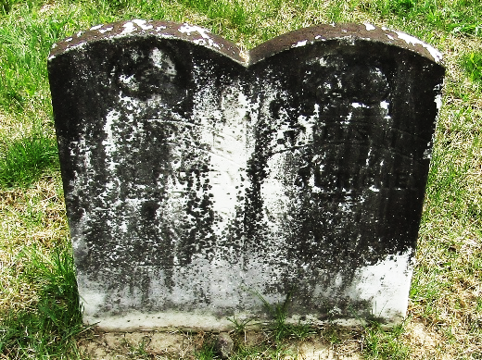

No further information found at this time

