Mary S. Richey
October 6, 1847 – August 6, 1848

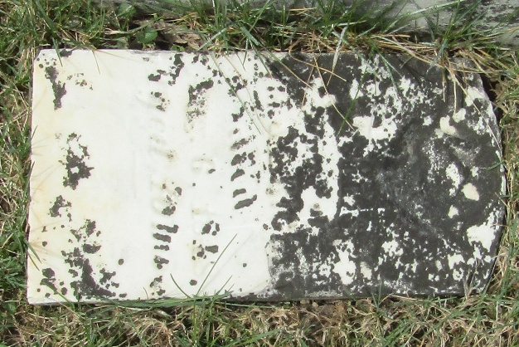

No further information found at this time

