Lydia (Sutton) Richey
May 10, 1812 – February 13, 1884

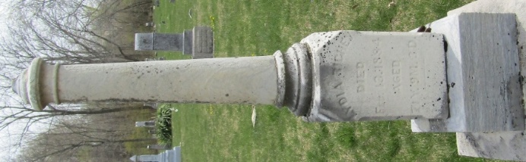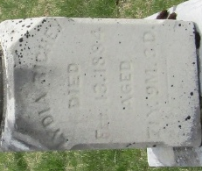

Lydia Richey

Died, At her home three miles north of Bluffton, Lydia Richey, widow of William S. Richey. Grandma Richey was born in Licking County, Ohio, May 10th, 1812, died Feb. 13th, 1884, aged 71 years, 9 months and 3 days.
The deceased immigrated with her father to this county and located near the present site of Murray, in the year 1838. She, with her husband, lived to see this then dense forest, cleared of its heavy timber, and settled with its thousands of people.
She was the mother of nine children, three of whom along with her husband, preceded her in death. She was a kind wife and mother.
The funeral services were held in the U.P. Church of Murray, conducted by Rev. J.H. Reider, of Bluffton.

Bluffton Chronicle, Wells County, Indiana
Thursday, February 21, 1884

