Zackary Taylor Richards
November 3, 1852 – June 9, 1923

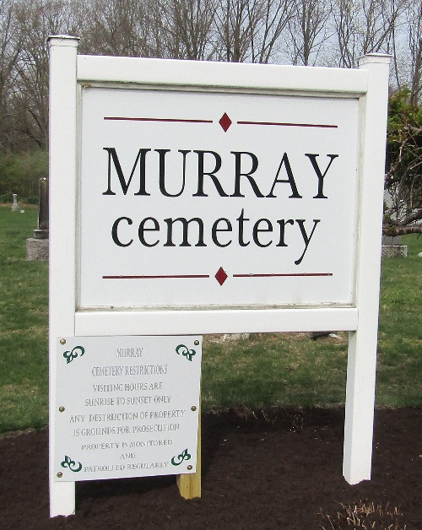

Zachary Richards Dies at Hospital
Funeral of Local Man Held at Christian Union Church Today

The funeral services of Zachary Taylor Richards, who died at the Wells County Hospital at 5 o'clock Saturday evening, was held at 2 o'clock this afternoon at the Christian Union Church in West Bluffton. Burial was at Murry.
Mr. Richards' death occurred at the Wells County Hospital, where he was taken several days ago, while suffering from cancer of the stomach. He had been sick for three months.
Born in Holmes County, Ohio, November 3, 1852, the son of Thomas and Anna C. (Lash) Richards, Zachary T. Richards was 70 years, 7 months and 6 days old at the time of his death. He had been a resident of Wells County for about forty-five years. During that time, he worked at the Frazier tile mill for twelve years.
The marriage of Mr. Richards to Margaret J. Bender took place in this city in March 1880. They were the parents of nine children, four of whom are deceased. Those surviving are; Addie Murphy, Vivian, La.; Clint Richards, Bluffton; Homer C. Richards, Homer, La.; Maude Murphy, Vivian, La.; Mrs. H. O. Betz, Haynesville, La.; Mrs. Julia Hetrick of near Bluffton is a sister of the deceased. Five sisters have preceded him in death.

Unknown source

**
Indiana, U.S., Death Certificates, 1899-2017

Name Zackary Taylor Richards
Gender Male
Race White
Marital Status Married
Age 70
Birth Date 3 Nov 1852
Birth Place Holmes Co-Ohio
Death Date 9 Jun 1923
Death Place Bluffton, Wells, Indiana, USA
Death Registration Date 1923
Father Thomas Richards
Mother Anna C. Lash
Spouse Margaret J. Bender
Informant Clint Richards; Bluffton, Indiana
Burial June 11, 1923; Murray Cemetery

