Anna C. (Lash) Richards
January 3, 1824 – March 7, 1907

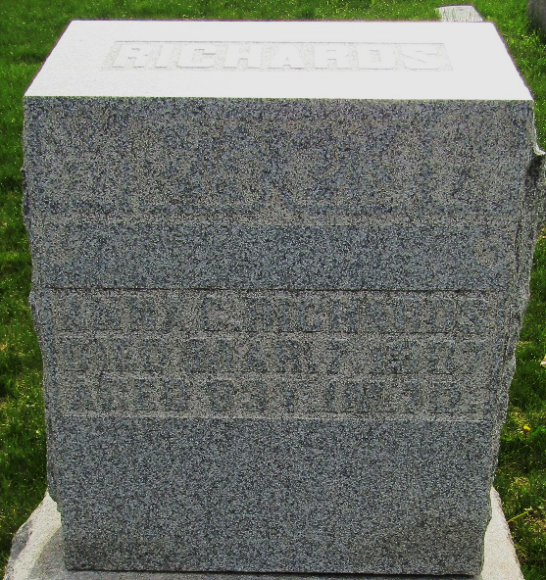

ANNA C. RICHARDS

Mrs. Anna C. (Lash) Richards, aged 83, died Thursday night at the home of her daughter, Mrs. Noah (Julia) Hedrick, four miles north of the city. Mrs. Richards had been ill for a long time and a stroke of paralysis proved fatal and caused her death.
The funeral was held at the home Sunday morning at 10 o'clock in charge of Rev. Fetro of the Pugney church and burial took place in the Murray Cemetery.

Unknown source

**
Indiana, U.S., Death Certificates, 1899-2017

Name Anna C Richards
[Anna C Lash]
Gender Female
Race White
Marital Status Widowed
Age 83
Birth Date 3 Jan 1824
Birth Place Pennsylvania
Death Date 7 Mar 1907
Death Place Lancaster, Wells, Indiana, USA
Death Registration Date 1907
Father Isaac Lash
Mother Rutt?
Informant Sarah Lash; Tocsin, Indiana
Burial March 9, 1907; Murray Cemetery

**
Anna C. Lash from tree Sheldon Family Tree-#2

Birth 31 Jan 1824 Pennsylvania, USA
Marriage 3 Nov 1842 Holmes, Crawford, Ohio, USA
Residence 1900 Wells, Indiana, USA
Death 7 Mar 1907 Wells, Indiana, USA
Father Isaac Lash
Mother "Catherine" Ruth (1806-1837)
Spouse Thomas A Richards (1823-1864)

