Hazel Adeline Powers
July 31, 1892 – August 2, 1910

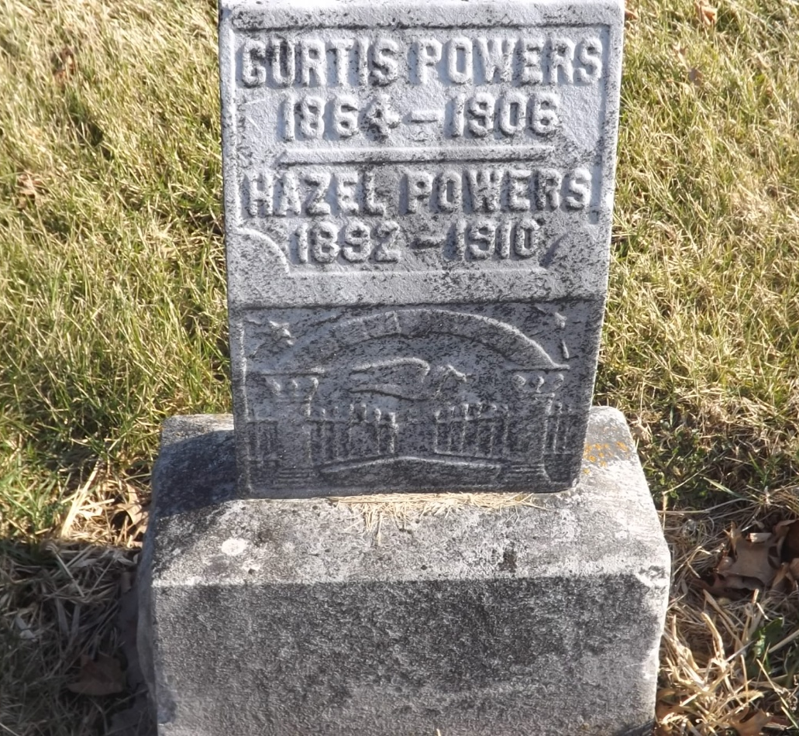
Photo by Jim Allen

Hazel Adeline Powers
Indiana, U.S., Death Certificates, 1899-2017
Name Hazel Adeline Powers
Gender Female
Race White
Marital Status Single
Age 17 years, 10 months
Birth Date 31 Jul 1910 [sic]
Birth Place Indiana
Death Date 2 Aug 1910
Death Place Fort Wayne, Allen, Indiana, USA
Death Registration Date 1910
Father Curtis Powers
Mother Sarah Picklehamer
Informant Mrs. Powers; Tocsin, Indiana
Burial Tocsin, Indiana

