Curtis Powers
August 15, 1864 – October 13, 1906

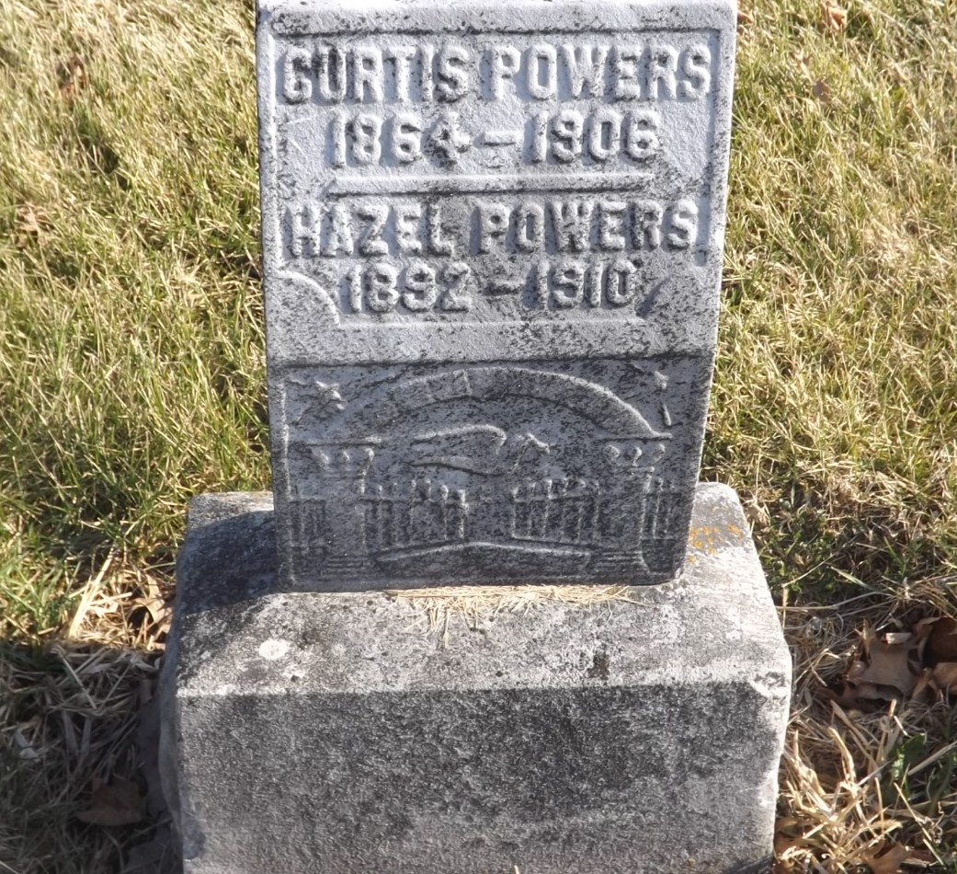
Photo by Jim Allen

Curtis Powers
Indiana, U.S., Death Certificates, 1899-2017
Name Curtis Powers
Gender Male
Race White
Marital Status Married
Age 42
Birth Date 15 Aug 1864
Birth Place New Richmond, Ohio
Death Date 13 Oct 1906
Death Place Tocsin, Wells, Indiana, USA
Father Jernid Powers
Mother Cathrine Pickelhamer
Informant Mrs. Curtis Powers; Tocsin, Indiana
Burial October 14, 1906; Murray Cemetery

