Leana (Schweikert) Plank
September 14, 1876 – February 21, 1932

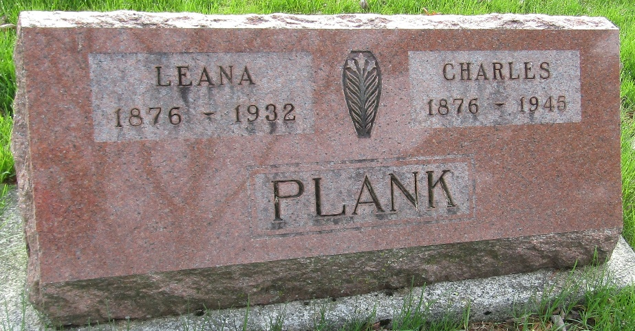

Mrs Lena Plank
Indiana, U.S., Death Certificates, 1899-2017
Name Mrs Lena Plank
Gender Female
Race White
Marital Status Married
Age 55
Birth Date 14 Sep 1876
Birth Place Germany
Death Date 21 Feb 1932
Death Place Bluffton, Wells, Indiana, USA
Death Registration Date 1932
Parents Unknown
Spouse Charles Plank
Informant Charles Plank; Fort Wayne, Indiana
Burial February 23, 1932; Murray Cemetery

