Francis E. Plank
February 28, 1913 – February 28, 1913

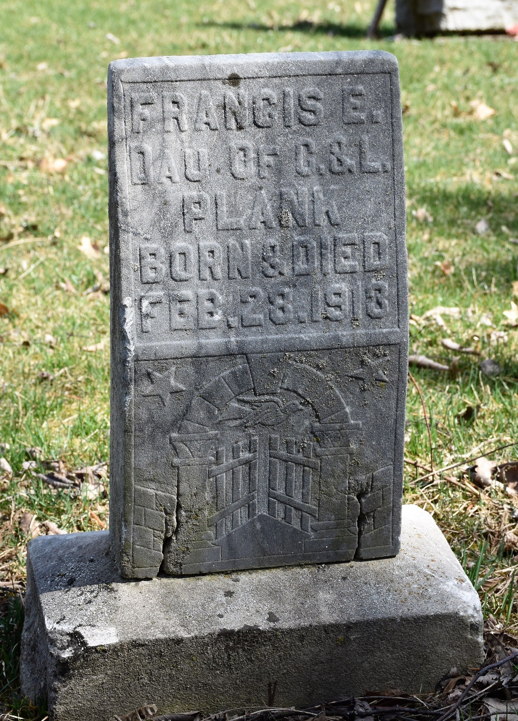
Photo by Colleen Sanders Broyles

Francis E Plank from tree Eason-Endicott Families
Birth 28 Feb 1913 Wells, Indiana, USA
Death 28 Feb 1913 Wells, Indiana, USA
Father Charles R Plank (1876-1945).
Mother Lena Schweikert (1876-1932

