Charles R. Plank
September 23, 1876 – February 22, 1945

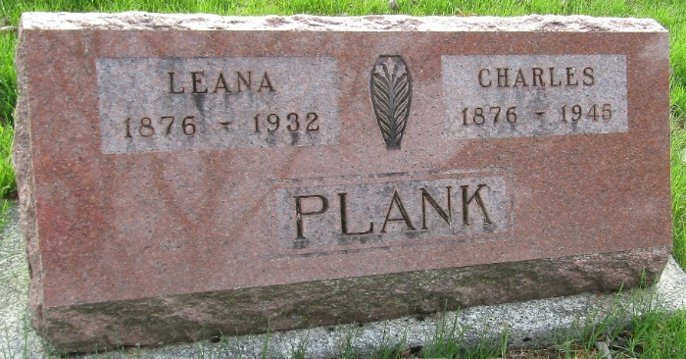

Charles R Plank
Indiana, U.S., Death Certificates, 1899-2017
Name Charles R Plank
Gender Male
Race White
Marital Status Married
Age 68
Birth Date 23 Sep 1876
Death Date 22 Feb 1945
Death Place Fort Wayne, Allen, Indiana, USA
Death Registration Date 1945
Parents Unknown
Spouse Lena; deceased
Informant Carl Kinsey; Uniondale, Indiana
Burial February 25, 1945; Murray Cemetery; Murray, Indiana
**
Charles R Plank from tree Eason-Endicott Families
Birth 23 Sep 1876 Wells, Indiana, USA
Marriage 28 Oct 1909 Miami, Indiana, USA
Residence 1930 Fort Wayne, Allen, Indiana, USA
Death 22 Feb 1945 Fort Wayne, Allen, Indiana, USA
Father Enos Plank (1847-1923)
Mother Sarah Frances Routh (1847-1927)
Spouse Lena Schweikert (1876-1932)

