Martin Perry
June 11, 1807 – March 28, 1870

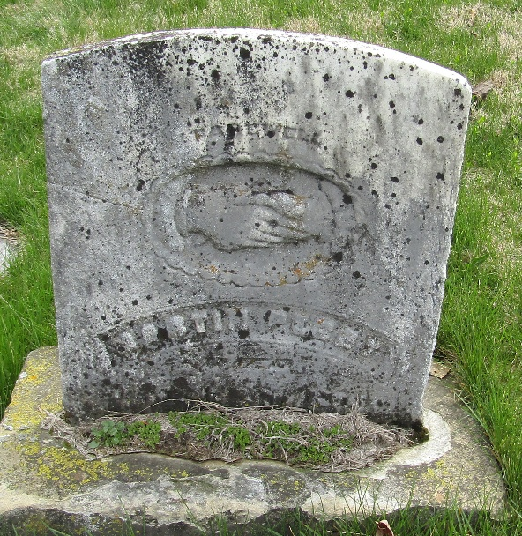

Martin Perry from tree Hans Mason's Tree
Birth 11 Jun 1807 Virginia, USA
Marriage 1 Apr 1853 Wells, Indiana, USA
Residence 1860 Wells, Indiana, USA
Death 28 Mar 1870 Bluffton, Wells, Indiana, USA
Father Henry William Perry (1774-1865)
Mother Sarah Franks (1784-1866)
Spouse Margaret Wilkin (1804-1850)
Spouse Elizabeth Nash (1831-1873)

