Margaret (Wilkin) Perry
August 2, 1804 – July 11, 1850

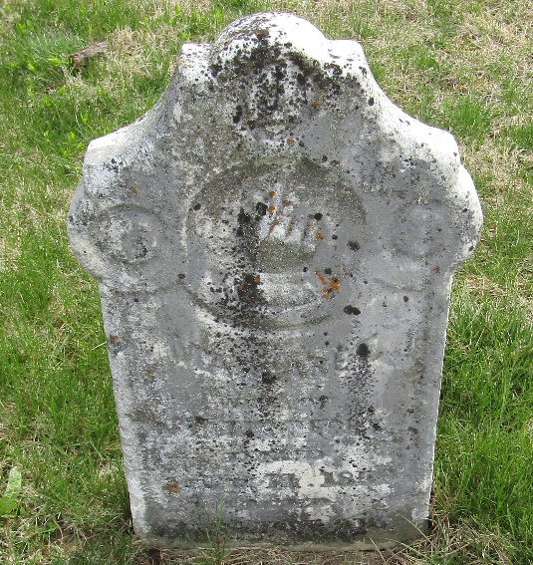

Margaret Wilkin from tree OttBilger Family Tree
Birth 2 Aug 1804 Ohio, USA
Marriage 12 Feb 1833 Harrison, Ohio, USA
Residence 1850 Wells, Indiana, USA
Death 11 Jul 1850 Bluffton, Wells, Indiana, USA
Father William Wilkin (1764-1808)
Mother Isabelle Munsey (1768-1849)
Spouse Martin Perry (1807-1870)

