Lucetta May (Sowards) Perry
April 7, 1866 - May 17, 1905

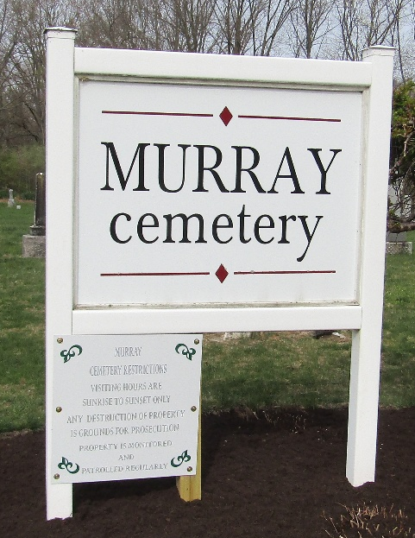

Lucetta May Perry
Indiana, U.S., Death Certificates, 1899-2017
Name Lucetta May Perry
[Lucetta May Sowards]
Gender Female
Race White
Marital Status Married
Age 39
Birth Date 8 Apr 1866
Birth Place Indiana
Death Date 17 May 1905
Death Place Lancaster, Wells, Indiana, USA
Death Registration Date 1905
Father Wesley Sowards
Mother Sarah President
Spouse Martin Perry
Informant Family; Craigville, Indiana
Burial May 19, 1905; Murray Cemetery
**
Lucetta May Sowards from tree Jean Family Tree
Birth 7 Apr 1866 Wells, Indiana, USA
Marriage 27 Aug 1885 Wells, Indiana, USA
Residence 1900 Wells, Indiana, USA
Death 17 May 1905 Wells, Indiana, USA
Father Wesley Sowards (1837-1889)
Mother Sarah E. Pruden (1840-1872)
Spouse Martin Mortimer Perry (1856-1923)

