Joseph H. Perry
March 14, 1868 – August 25, 1888

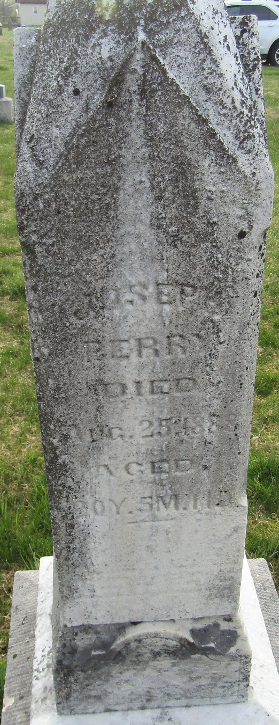

Joseph H Perry from tree OttBilger Family Tree
Birth 14 Mar 1868 Indiana, USA
Residence 1880 Wells, Indiana, USA
Death 25 Aug 1888 Wells, Indiana, USA
Father Martin Perry (1807-1870)
Mother Elizabeth Nash (1831-1873)

