Margaret (Morrison) Peppard
February 15, 1814 – July 1, 1853

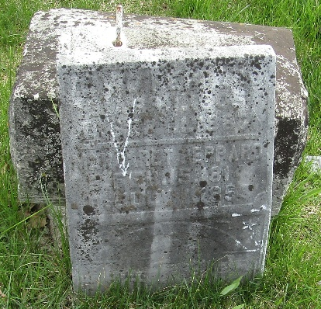

Margaret Morrison from tree Huff Family Tree
Birth 15 Feb 1814 Pennsylvania, USA
Marriage 4 Aug 1836
Residence 1850 Wells, Indiana, USA
Death 1 Jul 1853 Wells, Indiana, USA
Father Francis Morrison (1783-1824)
Mother Ann (Anna) Hill (1786-1871)
Spouse David Peppard (1805-1887)

