David Peppard
April 1, 1805 – September 1, 1887

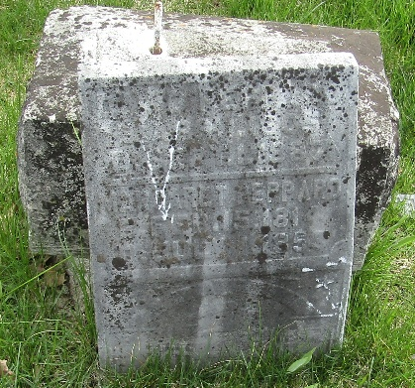

Obituary

David Peppard was born in Washington county, Penn., April 1st, 1805. When about 10 years of age he moved with his parents to Wayne county, Ohio, where he had his home till 1847, when he moved to Wells County, Indiana, where he remained till his death.
In 1836 he was married to Margaret Morrison and they lived together for 19 years when she died. They had eight children, five still living. In 1857 he was married to Mary Bender, who is still living to mourn her loss.
When a young man he was a member of the Baptist Church. After he was married, he with his wife went to the Presbyterian Church, there being no Baptist near his home. He remained a member of the Presbyterian Church till his death, which took place September 1st, 1887, aged 82 years and five months.

Bluffton Chronicle, Wells County, Indiana
Thursday, September 8, 1887, p. 3. c. 7

**
David Peppard from tree Morrison Family Tree
Birth 1 Apr 1805 Beaver, Beaver, Pennsylvania, USA
Marriage 4 Nov 1857 Wells, Indiana, USA
Residence 1880 Bluffton, Wells, Indiana, USA
Death 1 Sep 1887 Wells, Indiana, USA
Father Jonathan Peppard (1768-1843)
Mother Elizabeth Gilmore (1769-1824)
Spouse Margaret Morrison (1814-1853)

