Lemuel Paynter
October 17, 1813 – October 11, 1894

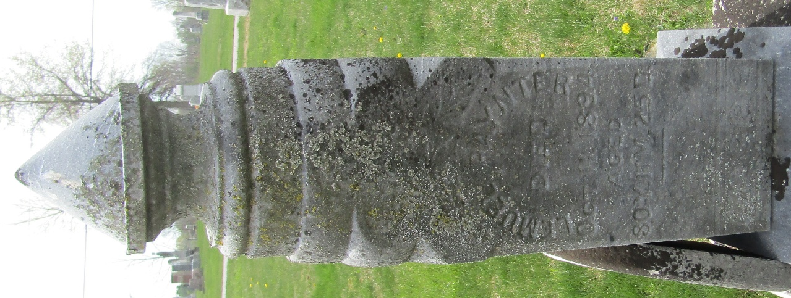

Lemuel Paynter from tree Garton Tree, the James Owen line
Birth 17 Oct 1813 Delaware, USA
Marriage 28 Dec 1839 Franklin, Johnson, Indiana, USA
Residence 1880 Wells, Indiana, USA
Death 11 Oct 1894 Wells, Indiana, USA
Father Richard Paynter (1785-1817)
Mother Hester Maull (Born 1788)
Spouse Eliza A Garton (1816-1870)

