John M. Paynter
March 2, 1849 – January 8, 1850

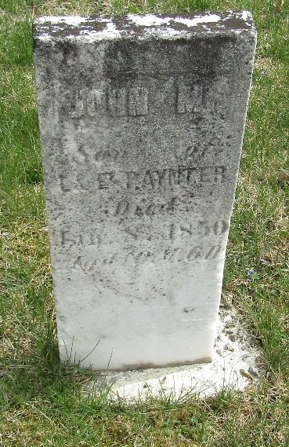

John M. Paynter from tree garton3.FBK_ 2022 Latest Updates
Birth 2 Mar 1849 Indiana, USA
Residence 1860 Bridgeton, Cumberland, New Jersey, USA
Death 8 Jan 1850 Wells, Indiana, USA
Father Lemuel Paynter (1813-1894)
Mother Eliza A Garton (1816-1870)

