Hettie Paynter
1856 – January 18, 1924

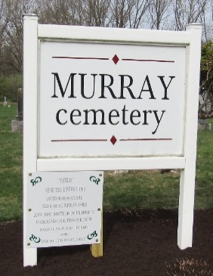

MISS HETTIE PAYNTER DIES AT INFIRMARY
Cancer of Liver Causes Demise of Well Known Lancaster Township Woman.

Miss Hettie Yaynter (sic), about 78 years old, who virtually her entire life had lived in Lancaster township, died of cancer of the liver this morning at 11;20 o’clock, at the county infirmary where she had been in a serious condition for several days.
Miss Paynter had been at the infirmary since Dec. 31. A year previous to that time she had lived with Mrs. Ed Vondersmith, a neighbor. She was born in Ohio, a daughter of Lemuel Paynter and Eliza Garton Paynter. For years she lived on a farm with her sister, Miss Catherine Paynter, who died in September 1922. A brother, John Paynter, is also deceased. She was a member of the Lancaster U. B. Church.

Bluffton Evening News, Wells County, Indiana
Saturday, January 19, 1924, p. 1, c. 4

**
Indiana, U.S., Death Certificates, 1899-2017
Name Hetie Paynter
Gender Female
Race White
Marital Status Single
Age 68
Birth Date 1856
Birth Place Indiana
Death Date 18 Jan 1924
Death Place Harrison, Wells, Indiana, USA
Death Registration Date 1924
Father Lemuel Paynter
Mother Eliza Garton
Informant Stanley Miller; County Infirmary; Wells County
Burial January 21, 1924; Murray Cemetery

