Elizabeth (Garton) Paynter
September 23, 1806 – November 13, 1870

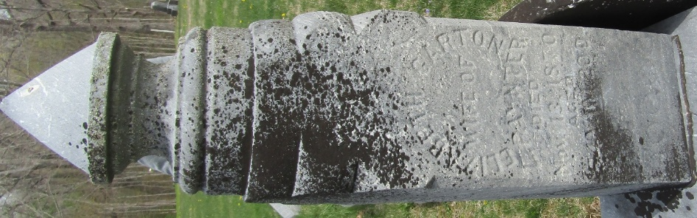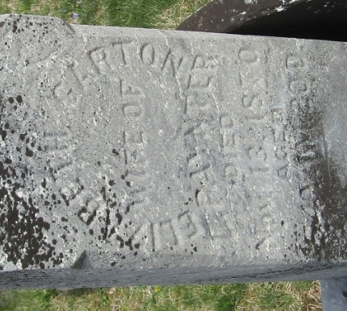

Eliza Garton from tree Lee Alan Souder Family Tree JULY 2026
Birth 23 Sep 1816 Cumberland, New Jersey, USA
Marriage 28 Dec 1839 Franklin, Indiana, USA
Residence 1870 Bluffton, Wells, Indiana, USA
Death 13 Nov 1870 Wells, Indiana, USA
Father Jonathan Garton (1796-1879)
Mother Elizabeth "Betsy" Souder (1796-1872)
Spouse Lemuel Paynter (1813-1894)
7759 People 4 Records 6 Sources

