James Luther Patterson
December 23, 1903 – March 23, 1904

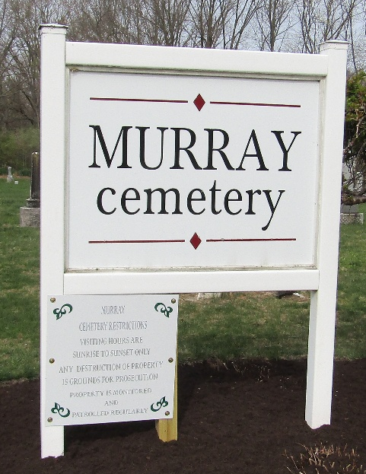

James Luther Patterson
Indiana, U.S., Death Certificates, 1899-2017
Name James Luther Patterson
Gender Male
Race White
Marital Status Single
Age 3/12
Birth Date 23 Dec 1903
Birth Place Lancaster Township
Death Date 23 Mar 1904
Death Place Lancaster, Wells, Indiana, USA
Death Registration Date 1904
Father Left blank
Mother Allace Patterson
Informant J. D. Woodward
Burial March 24, 1904; Murray Cemetery

