Elizabeth M. (Crum) Patten
April 15, 1820 – December 24, 1884

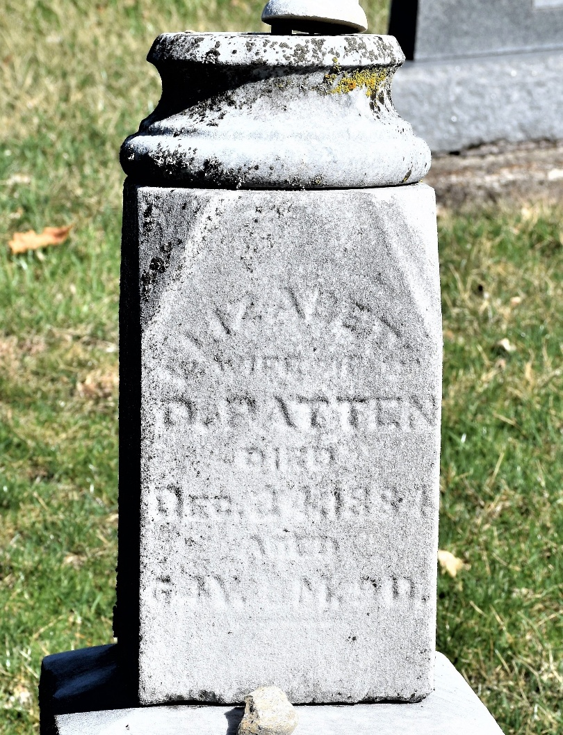
Photo by Colleen Sanders Broyles

Elizabeth M. Crum from tree Patten Family Tree (1)
Birth 15 Apr 1820 Menallen, Adams, Pennsylvania, USA
Marriage 23 Aug 1838 Richland, Ohio, USA
Residence 1880 Sharon, Richland, Ohio, USA
Death 24 Dec 1884 Bluffton, Wells, Indiana, USA
Father Moses Crum (1788-1873)
Mother Margarete Rex (1788-1882)
Spouse David Patten (1818-1900)

