William Willis Parkison
November 30, 1858 – September 10, 1891

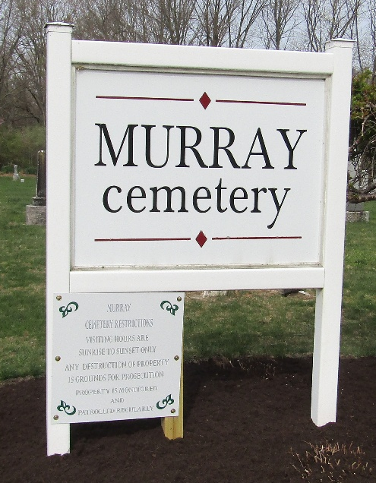

William Willis Parkison from tree Morton
Birth 30 Nov 1858 Wells, Indiana, USA
Residence 1880 Wells, Indiana, USA
Death 10 Sep 1891 Wells, Indiana, USA
Father Stephen Parkison (1821-1865)
Mother Ann Jane Riddle (1825-1900)

