William J. Parkison
October 25, 1845 – July 29, 1931

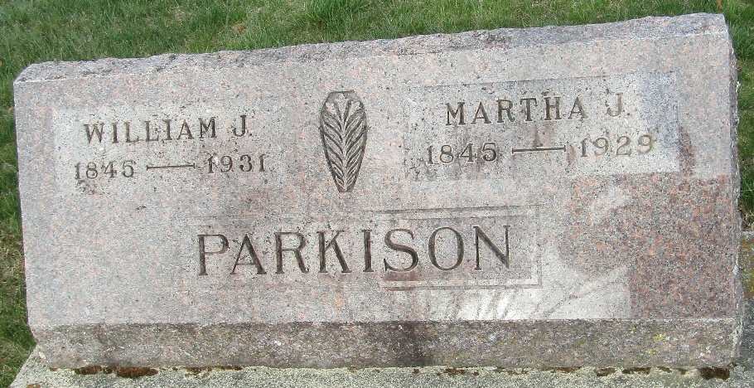

William J. Parkson, son of Ebenezer and Isabella (Johnston) Parkison, was born in Wayne County, Ohio, October 25, 1845. In September 1847, he was brought by his parents to Wells County, they settling on section 4 of Lancaster Township. He was reared on the home farm to agricultural pursuits, remaining with his parents until attaining his majority.
When he was twenty-one years of age he began life for himself. May 30, 1866, he was united in marriage to Miss Martha J. Maddux, who was born in Wells County, October 28, 1845, a daughter of Jacob Maddux, who settled in the county in 1888. Mr. and Mrs. Parkison are the parents of six children: Delner Grant, Charles F., Anna Belle, Harry C., Minona F. and Oliver W.
Mr. and Mrs. Parkison began housekeeping on a farm owned by John Osborne, located in Jefferson Township, where they spent one year. They then removed to section 83 of the same township and commenced improving a small farm. Two years later they removed to Cass County, Indiana, where they followed farming for three years, returning to the homestead of Mr. Parkison's parents, in Lancaster Township. Two years later they went to Allen County, returning to the old homestead in Wells County in 1880, where Mr. Parkison has since been extensively engaged in the manufacture of tile and terra cotta at Kingsland Station in connection with his farming pursuits. He has made most valuable improvements in ovens used for burning tile and terra cotta, and for utilizing the heat in drying sheds, by which he believes two-thirds of the fuel generally used can be saved.
Unknown source
**
Indiana, U.S., Death Certificates, 1899-2017
Name William J. Parkison
Gender Male
Race White
Marital Status Widowed
Age 85
Birth Date 25 Oct 1845
Birth Place Ohio
Death Date 29 July 1931
Death Place Ossian, Wells, Indiana, USA
Death Registration Date 1931
Father Ebenezer Parkison
Mother Isabelle Johnson
Spouse Martha Jane
Informant H. C. Parkison; Ossian, Indiana
Burial July 30, 1931; Murray Cemetery

