Stephen Parkison
March 30, 1821 – May 11, 1865

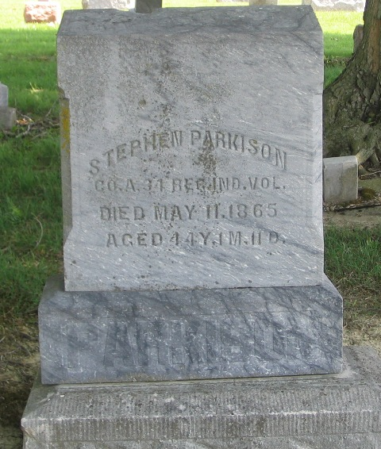
Photo by Barbara Baker Anderson

Stephen Parkison from tree Morton
Birth 30 Mar 1821 Wayne, Ohio, USA
Marriage 29 Jun 1848 Wells, Indiana, USA
Residence 1860 Wells, Indiana, USA
Death 11 May 1865 Brazos, Texas, USA
Father Thomas Parkison (1780-1837)
Mother Eunice Coe (1783-1852)
Spouse Ann Jane Riddle (1825-1900)

